follow us @CISI  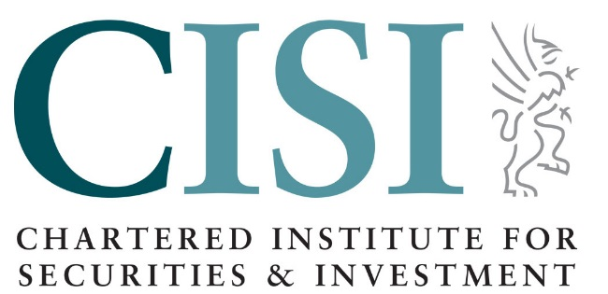 | PRESS RELEASE  21December 2020

CISI and Chartered Banker Institute welcome important update to the FCA Register on membership

Two leading financial services professional bodies are delighted that the recently updated FCA Register , which went live on 14th December, now includes details regarding the professional memberships and affiliation of individuals.

Simon Thompson, Chief Executive, Chartered Banker Institute said:
“Membership of a Chartered body, is a public demonstration that the individual has made an active commitment to maintaining high professional standards, continues to update their professional knowledge and skills, and acts with integrity. I am, therefore, delighted that consumers can now see this clearly via the FCA Register and can make informed choices about seeking the services of a suitably qualified professional, in the knowledge that their advisor is a member of a Chartered body.”
CISI’s CEO, Simon Culhane, Chartered FCSI added:
“This is very positive step for consumers who can now easily see and choose a Chartered Professional to provide them with financial advice. We encourage all members of Professional Bodies to ensure their details are accurate on the new register.”

ENDS

Notes for Editors:
For further information on the Chartered Institute for Securities & Investment contact : Lora Benson +44 20 7645 0662/ +44 7801 521034 or lora.benson@cisi.org
About Chartered Institute for Securities & Investment
The CISI’s mission is to help members attain, maintain and develop their knowledge and skills and to promote the highest standards of ethics and integrity in the securities and investment profession.
Based in the City of London, with origins in the London Stock Exchange, the CISI is a global organisation with representative offices in financial centres such as Barcelona, Colombo, Dubai, Dublin, Edinburgh, London, Manila, Mumbai and Nairobi. We work in close cooperation with regulators, firms and other professional bodies worldwide and over 40,000 examinations were sat in 80 countries in the last twelve months. With 45,000 members in 104 countries the CISI is the professional body which sets examinations and offers qualifications for those working in or looking to establish a career in the financial planning, wealth management and capital markets profession.
For further information on the Chartered Banker Institute contact:
Matthew Ball, Head of Public Affairs, Chartered Banker Institute
Tel: +44 (0)7720 684226 or E-mail: matthew.ball@charteredbanker.com
About the Chartered Banker Institute
The Chartered Banker Institute (“the Institute”) is the oldest professional banking institute in the world. The Institute was founded in 1875, operates in all UK nations, and has a significant and growing international presence.
The Institute has driven an agenda of ethical professionalism throughout its existence; promoting professional standards for bankers, providing professional qualifications for retail, commercial and private bankers in the UK and overseas, and offering professional membership to qualified individuals. The Institute currently has around 30,000 members in 108 different countries.

https://register.fca.org.uk/s/

